INTRODUCTION

  - PROJECT OVERVIEW
The ‘Sports Management System’ is a fully functional web-based application that evolves in response to the state of sports management. It is utilized to solve existing management issues, establish a regular schedule, and properly organize sporting events.
This ‘Sports Management System is being developed to aid in the easier and more secure management of tournaments. This will collect information about players and facilitators in order to send those SMS notifications regarding time, range, and venue schedules in various/specific sports fields.
The Sports Event Management System simply works that focuses on the recreation. Planning, organizing, directing, controlling, budgeting, leading, or analyzing any organization or corporation in the sports industry requires a diverse set of talents.
This Sports Event Management System will also be in charge of bracketing the matches and could provide just outcomes for the winners based on an exact summing of each match’s scores.

1.2 Introduction to Tools
1.2.1 PHP
PHP is pleasingly zippy in its execution, especially when compiled as an Apache module on the UNIX side. The PHP Hypertext Preprocessor (PHP) is a programming language that allows web developers to create dynamic content that interacts with databases. PHP is basically used for developing Web based software applications
PHP started out as a small Open source project that evolved as more and more people found out how useful it was. Rasmus Lerdorf unleashed the first version of PHP way back in 1994.
- PHP is a recursive acronym for "PHP: Hypertext Preprocessor".
- PHP is a Server side scripting language that is embedded in HTML. It is used to manage dynamic content, databases, session tracking, even build entire e-commerce sites.
- It is integrated with a number of popular databases, including MySQL, Postgre SQL, Oracle, Sybase, Informix, and Microsoft SQL Server.
- PHP is pleasingly zippy in its execution, especially when compiled as an Apache module on the UNIX side. The MySQL server, once started, executes even very complex queries with huge result sets in record-setting time.
- PHP supports a large number of major protocols such as POP3, IMAP, and LDAP. PHP4 added support for Java and distributed object architectures (COM and CORBA), making entire development a possibility for the first time.
- PHP is forgiving: PHP language tries to be as forgiving as possible.

1.2.2 SQL Server
Microsoft SQL server is a complete database and analysis solutions for rapidly delivering the next generation of scalable applications. SQL server is a key component in supporting ecommerce, line of business and data warehousing applications, while offering scalability necessary to support growing, dynamic environment. SQL Server includes rich support for XML other internet language format. SQL Server takes full advantage of Microsoft Windows by integrating with Active directory services and supporting up to 32-bit processors and 4GB RAM.
SQL Server includes a number of features that support ease of installation, deployment and use: scalability, data warehouse and system integration with other server software. SQL Server is a relational database management system (RDBMS) developed by Microsoft. It is primarily designed and developed to compete with MySQL and Oracle database.
SQL Server supports ANSI SQL, which is the standard SQL (Structured Query Language) language. However, SQL Server comes with its own implementation of the SQL language, TSQL (Transact-SQL). T-SQL is a Microsoft propriety Language known as Transact-SQL. It provides further capabilities of declaring variable, exception handling, stored procedure, etc. SQL Server. Management Studio (SSMS) is the main interface tool for SQL Server and it supports both 32bit and 64-bit environments.

SYSTEM STUDY

2.1 Introduction
A system is set of interrelated elements that collectively work together in order to achieve a common goal. A sub system is that part of a system that carries one part of a system function. System study refers to the process of examining business situations with the aim of improving it through better procedure and method. System designing is the process of planning a new business system or one to replace all component and existing system. However, before tis planning one must have true idea about existing system.

2.1.1 FEASIBILITY STUDY
An important outcome of the preliminary investigation is the determination that the system requested is feasible. The feasibility of the project can be ascertained in terms of technical factors, or both. There are three aspects in the feasibility study portion of the preliminary investigation.
- Technical Feasibility
- Economic Feasibility
- Operational Feasibility

Technical Feasibility
Can the work for the project be done with equipment, existing software technology and available personnel? If new technology is needed, what is the likelihood that it can be developed? Technical feasibility refers to the ability of the process to take advantage of the current state of the technology in pursuing further improvement.
It was found that the firm currently using computers and printers for creating documents and drawings. As this machine is configured for the basic hardware requirements for installing dot net framework the equipment is feasible for installing the designed software. The operating system is installed in these computers is compatible for installing the dot net framework. The staff in the firm is now manually preparing all functions mentioned in the study of the software. So if they get trained with this designed software, new appointments can be avoided and thus the system will run smoothly.

Economic Feasibility
Are there sufficient benefits in creating the system to make the cost acceptable? Or, are the costs of not creating the system so great that it is advisable to undertake the project? This involves the feasibility of the proposed project to generate economic benefits by swapping to this software system the firm is completely wiped out from its manual paper works and files. Now the entire system will be controlled and maintained by the newly developed software that doesn’t require any kind of these existing materials. So the cost is reduced and the burden of keeping these materials for the lifetime is evacuated forever. The entire control of each function comes under one umbrella and thus for reporting the required information is reduced.
Operational Feasibility
Will the system be used if it is developed and implemented? Will there be resistance from users that will undetermined the possible application benefits? Since the software system is designed in a user-friendly manner. It is easy to understand the working process for a computer aware person. Training is provided for the users of this software. The benefits are thoroughly practiced at the time. The burdens that they currently followed are compared with these software functions and visualized how ease the software handles those situations. Thus they are motivated to shift to the new environment without any fake thoughts in mind.

2.2 Existing System
In the existing Sports Event Management system, students are not able to get proper information about the games conducted in various colleges. The student needs to spend the time to get the information about the game. The student should attend the venue to be registered for the game, which takes a lot of time.
Disadvantage of Existing System:
- Lot of paper work.
- Checking the student details repeatedly.
- Needs to spend the time to get the information about the game and participated.
2.3 Proposed System
The project brings the entire manual process of sports event management online, which is built using PHP as a front end and SQL Server as a backend. The main purpose of this project is to simplify the process of handling each sports event by providing a web interface for admin and teacher. By using this system, teachers can save a lot of time and effort.
Advantage of Proposed system:
- Overcomes the dependency of a single person handling all the sport activity.
- Multiple teacher can use the web interface to login and perform the desired task.
- Easy results generation and view rankings.
- Easy to access the system anywhere and anytime.

2.4 Techniques for System study
The analyst collects data from two principle sources.
- Written documents
- Data from the persons who are involved in the operation of the system under study.
The different fact finding techniques are:

- Data carriers
- Questionnaires
- Personal interviews
- Observations
- Research
Data carrier
In this step, the analyst gathers and gathers all documentation related to data carriers for the system under investigation. Examples of data carriers are forms, records, reports, manuals and procedures.
Questionnaires
The questionnaire is an important and often effective type of correspondence. For example, it may be the only efficient method of obtaining response from a large number of people particularly if they are widely scattered or in a remote locations. Questionnaire should be brief in order to increase the promptness and portability of correspondence.
Personal interviews
An interview is a person-to-person communication. The analyst is more of a receiver than a sender when conducting an interview. The interviews are helpful for the analyst to explain the actual aim of the interview. The analyst is primarily seeking information. Therefore, he must be a good listener. Interviews are critical because people are the most important ingredients of any system.

Observation
In this method analyst observes the operation of the ongoing system and begins to formulate questions and draw conclusions based on what he/she observed. Skilled analyst is able to observe things and recall it in a quick way.
Research
The final fact-finding techniques, research is of particular importance when a new application is being considered because it is a method of simulating creative approach to the problem solving. All the fact-finding methods that are discussed are in house research. However there are many outhouse source of information, these include trade and professional publication, computer oriented news publication etc. an analyst should establish and maintain contacts with officials in other companies. One highly recommended method of making such contact is membership and active participation in professional societies. Also visit various companies with similar problems and exchanging information and ideas will helpful for the analyst for attaining knowledge. This knowledge will help the analyst for making various decisions. The fact-finding techniques used in our project is data carriers and interviews, to collect data for computerizing the existing system. In data carriers, we gathered and organized all documentations related to data carries for the system under investigation. In interviews, we have collected the information regarding the existing system and drawbacks to be cleared.

SYSTEM ANALYSIS

3.1 Introduction
A system is set of interrelated elements comprised and operating together to achieve goals. In computer field a system can be regarding as a set of interacting elements responsible for input to produce outputs. The inputs of system are considered as raw data refined outputs are called information. It may be better to define the term “System Analysis” and “System Analyst” in the context. System analysis is general term refer to an orderly structured process for an orderly structured process for identifying and solving problems. A system analyst is an individual who performs the system analysis during any or all lifecycle phases of a business information system.
System Analysis is a detailed study of the various function performed by the system and the relationship within and outside of the system. In this phase, the problem is identified and alternates system solution for solving it is recognized. System Analysis not only includes the process of synthesis, which is a process of putting parts together to form a new product. Analysis involves the requirement identification and specification.
3.2 Software Requirement Specification
3.2.1 Hardware specification
Processor - Intel Pentium
RAM - 4GB
Keyboard - Any
Monitor - Any
Printer - Any
CD drive - Any
3.2.2 Software Specification
Operating System - Windows 10
Front End - PHP
Back End - MySQL

SYSTEM DESIGN

4.1 Introduction
The design phase focuses on the detailed implementing procedural flowchart of the system recommended in the feasibility study. Emphasis in translating performance specification into design specification. The design phase is a translation from a user-oriented document to the programmers or database personal. System design aims to identify the modules and how they interact with each other to procedure-desired results. At the end of system design all data structures, file formats, output formats, as well as the major modules in the system and their specifications and desired

4.2 Module Specification
The Sports Management System consists of two users. They are Admin, Teachers/Coach. They also consist of various modules in it. They can register or login into the system to avail the services at the time of the event conducting. Admin manages the entire activities performed in the system.
The system consist of the following Modules:
- Registration / Login Module
- View Module
- Add and Generate Module
- Registration / Login Module
The user of the system is Admin and teachers / facillators. They wants to register into the system. If the facilitators already have an account, they can login into the system directly. By login in the system, user can easily find which event is conducting at the right time. Moreover, the system provides a secure registration for the users.
- View Module
In this module the view module can view all the details in the Sports Management System. There are two users in this Sports Management System. They are;
- Admin
- Teacher / Facilitator
Here, Admin add Sports events, student, assign the teacher for the event and teacher can view students and their details. All this process are controlled by the Admin.
- Add and Generate Module
In this module, the admin can add student, create sports events and tournaments, and generate result and teacher can view and generate result.

4.3 Input Design
Input designing is the process of converting user-oriented inputs into computer-based formats. Input is the source of data for processing. The inputs should be designed in such a manner that to control the errors entered by data entry operators.
The input forms used are:
FORMS:
- Admin
- FRM_LOGIN
This form is used to login into the system by a valid email and password for Admin and User.
- FRM_ENTRY
This form is used to add facilitator, sport type, game type, game mode, player, schools, venue and users into the database and also view them.
- FRM_SPORTS
This form is used to create a new sports type and view them.
- FRM_TOURNAMENT
This form is used to create new tournaments and publish result and also edit the add result for the event.
- FRM_GAMERESULT
This form is used to view the tournament details and views the published result.
- FRM_PARTICIPANTS
This form is used to add participants to the system and view them.

- User
- FRM_TEAM
This form is used to view scheduled team game.
- FRM_DOUBLE
This form is used to view scheduled double team game.
- FRM_SINGLE
This form is used to view scheduled single player game.
- FRM_RESULT
This form is used to add result for conducted events and views the add result.

4.4 Output Design
An output is the most important and direct source of information to the user. Efficient and intelligent output design improves the system relationship with the user and helps in decision-making.
Once the output required are identified the output device used also should be determined factors like compatibility of the output device used also should be determined factors like compatibility of the output device with the system response requirement should be considered while deciding the output device. They are designed in such a way that all required information’s are conveyed to the user in a very clear and efficient way.
4.5 Database Design
Database design is the process of producing a detailed data model of a database. This data model contains all the needed logical and physical design choices and physical storage parameters needed to generate a design in a data definition language, which can then be used to create a database. A fully attributed data model contains detailed attribute for each entity.
The term database design can be used to describe many different parts of the design of an overall database system. Principally, and most correctly, it can be thought of as the logical design of the base data structures used to store the data. In the relational model these are the tables and views. In an object database the entities and relationship map directly to object classes and named relationship. However, the term database design could also be used to apply to the overall process of designing, not just the data structures, but also the forms and queries used as part of the overall database application within the database management system (DBMS).
The process of doing database design generally consists of a number of steps which will be carried out by database designer. Usually, the designer must:
- Determine the data to be stored in the database.
- Determine the relationship between the different data elements.
- Superimpose a logical structure upon the data on the basis of these relationships.

Within the relational model the final step above can generally be broken down into two future steps that of determining the grouping of information within the system, generally determining what are the basis objects about which information is being stored, and then determining the relationship between these groups of information, or objects. This step is not necessary with an object database.

TABLES
- FACILITATOR
This table contains the information of the facilitator/teacher.
Primary key: facilitator_id
Field Name | Date Type | Size | Description
facilitator_id | int | 11 | Facilitator ID
facilitator_name | varchar | 30 | Facilitator Name
facilitator_gender | varchar | 30 | Facilitator Gender
facilitator_address | text | 30 | Facilitator address
facilitator_contact | varchar | 30 | Facilitator contact details
facilitator_status | varchar | 30 | Facilitator working status
facilitator_code | varchar | 30 | Facilitator code
Table 4.5.1 Facilitator
- SCHOOLS
This table contain the information about school.
Primary key:school_id
Field name | Data type | size | description
school_id | int | 11 | School id
school_name | tarchar | 30 | School name
school_address | text | 30 | School address
school_code | varchar | 30 | School code
Table 4.5.2 Schools
- PLAYER
This table contain the information about the player.
Primary key: player_id
Field Name | Data type | Size | Description
player_id | Int | 11 | Player id
player_name | Varchar | 30 | Player name
player_age | Int | 11 | Player age
player_course | Varchar | 30 | Player course
player_address | Text | 30 | Player address
player_gender | Varchar | 30 | Player gender
school_code | Varchar | 30 | School code
sports_code | Varchar | 30 | Sports code
contact | Int | 20 | Contact
player_code | Varchar | 30 | Player code
Table 4.5.3 Players
- SPORTS
This table contain the information about sports events.
Primary key: sport_id
Field name | Data type | size | Description
Sport_id | Int | 11 | Sport id
Sport_name | Varchar | 30 | Sport name
Sport_type_code | Varchar | 30 | Sport type code
Game_type_code | Varchar | 30 | Game type code
No_of_player | Int | 11 | No of players in the team
Sport_code | Varchar | 30 | Sport code
Is_default | varchar | 30 | Default
Table 4.5.4 Sports

- TOURNAMENT
This table contain the information about tournaments.
Primary key: tour_id
field name | Data type | size | Description
Tour_id | Int | 11 | Tournament id
Tour_name | Varchar | 30 | Tournament name
Tour_code | Varchar | 30 | Tournament code
Table 4.5.5 Tournament
- GAME TYPE
This table contain the information about game type.
Primary key: game_type_id
Field name | Data type | Size | Description
Game_type_id | Int | 11 | Game id
Type_of_game | Varchar | 30 | Type of game
Sports_type_code | Varchar | 30 | Type of sports code
Number_of_scoring | Int | 11 | Number of scoring
Game_type_code | Varchar | 30 | Type of game code
Table 4.5.7 Game type
User/facilitator
Authentication
Sport managementsystem
match result
players
match schedule
Valid email id/password
Invaild
tbl_login
match_resulr
players
match_schedule
Add/edit
View
view
view
- GAME TYPE MODE
This table contain the information about mode of game type.
Primary key: mode_id
Field name | Data type | Size | Description
Mode_id | Int | 11 | Mode id
Game_type_code | Varchar | 30 | Type of game code
Mode_name | Varchar | 30 | Mode name
Mode_code | Varchar | 30 | Mode code
Table 4.5.7 game type mode

- GAME RESULT
This table contain the result of the matches conducted.
Primary key: game_result_id
Field name | Data type | Size | description
Game_result_id | Int | 11 | Game result id
Match_code | Varchar | 30 | Match code
Sport_code | Varchar | 30 | Sports code
Sport_type_code | Varchar | 30 | Sports type code
School_code | varchar | 30 | School code
Final_score | varchar | 30 | Final score
Position_code | Varchar | 30 | Position code
Game_result_code | Varchar | 30 | Game result code
Table 4.5.8 game result
- GAME RESULT POSITION
This table contain the information about standing of team.
Primary key: position_id
Field name | Data type | size | description
Position_id | Int | 11 | Position id
Position_name | Varchar | 30 | Position name
Position_code | Varchar | 30 | Position code
Table 4.5.9 game result position
- USERS
This table contain the information about user id & password.
Primary key: user_id
Field name | Data type | size | description
User_id | Int | 11 | User id
Name | Varchar | 30 | Name
Username | Varchar | 30 | Username
Password | Varchar | 30 | Password
Table 4.5.10 Users

- VENUE
This table contain the information about the venue.
Primary key: venue_id
Field name | Data type | size | Description
Venue_id | Int | 11 | Venue id
Place | Varchar | 30 | Place
Venue_status | Varchar | 30 | Venue status
Venue_code | Varchar | 30 | Venue code
Table 4.5.11 Venue

- SCHOOL YEAR
This table contain the information about year.
Primary key: sy_id
Field name | Data type | Size | Description
Sy_id | Int | 11 | Year code
School_year | Int | 11 | School year
Sy_code | Varchar | 30 | School year code
Is_default | Varchar | 30 | Default
Table 4.5.12 school year

- MATCH SCHEDULE
This table contain the information about the matches scheduled.
Primary key: match_id
Field name | Data type | Size | description
Match_id | Int | 11 | Match id
Type_code | Varchar | 30 | Type code
Tour_code | Varchar | 30 | Tournament code
Sport_code | Varchar | 30 | Sports code
Facilitator_code | Varchar | 30 | Facilitator code
Venue_code | Varchar | 30 | Venue code
Match_date | Int | 11 | Match date
Match_time | Int | 11 | Starting time
time_end | Int | 11 | Time end
Match_code | Varchar | 30 | Match code
Sy_code | Varchar | 30 | Year code
School_code | Varchar | 30 | School code
Sport_type_code | Varchar | 30 | Sports type code
Game_type_code | Varchar | 30 | Game type code
Player_code | Varchar | 30 | Player code
Is_have_result | Varchar | 30 | Is have result
Match_status | Varchar | 30 | Match result
Table 4.5.13 match schedule

- SPORTS TYPE
This table contain the information about sports type.
Primary key: sport_id
Field name | Data type | Size | description
Sport_id | Int | 11 | Sports id
Sport_type_code | Varchar | 30 | Sports type code
Sport_type | Varchar | 30 | Sports code
Table 4.5.14 sports type

- TOURNAMENT TYPE
This table contain the information about tournament type.
Primary key: id
Field name | Data type | size | description
Id | Int | 11 | Tournament id
Type | Varchar | 30 | Tournament type
Type_code | Varchar | 30 | Tournament type code
Table 4.5.15 tournament type

DATA FLOW DIAGRAM

4.6 Data Flow Diagram
Data flow Diagram is the important structure tool. A Data Flow Diagram models a system by using external entries from which data flows to a process which transforms the data and create output data which goes into other process as output.
The main merit of Data Flow Diagram is that it provide an overview of what data a system would process, what transformation of data are done, what files are used and where the results flow. The graphical representation of the system makes it good communication tool between the user and analyst.
It is difficult to understand the business through verbal description alone. Here Data Flow Diagram helps in illustrating the essential components of a process and the way they interact.
The symbols used Data Flow Diagram has been explained below.
In a DFD, there are mainly four symbols
- A square defines a source of destination of system data.

- An arrow identifies data flow or data in motion. It is a pipeline through which information flows.

- An arrow identifies data flow or data in motion. It is a pipeline through which information flows.

- An open rectangle is a data source or data at rest or a temporary storage of data constructing the DFD.

LEVEL 0

User
Sports management system
User
Request
Response

Fig 4.6.1 Level 0 DFD

LEVEL 1
Admin
Authentication
Sport management
system
manage user
manage sports events
manage sports scheduling system
Sports management
Valid email id/
password
Invaild
tbl_login

Fig 4.6.2 Level 1 DFD

LEVEL 1.1

Admin
Authentication
Sport management system
manage user
manage sports events
manage tournament
Valid email id/password
Invaild
tbl_login
user
sports
tournament
Add/edit
View
Add/edit
View
View
Add/ edit

Fig 4.6.3 Level 1.1 DFD

LEVEL 1.2
Admin
Authentication
Sport management system
manage facilitators
manage players
manage match scheduling
Valid email id/password
Invaild
tbl_login
facilitator
players
match_schedule
Add/edit
View
Add/edit
View
View
Add/edit

Fig 4.6.4 Level 1.2 DFD

LEVEL 1.3

Admin
Authentication
Sport management system
manage result
Valid email id/password
Invalid
tbl_login
game_result
Add/edit
view

Fig 4.6.5 Level 1.3 DFD
LEVEL 2
User/facilitator
Authentication
Sport management system
match result
players
match schedule
Valid email id/password
Invalid
tbl_login
match_result
players
match_schedule
Add/edit
View
view
view

Fig 4.6.6 Level 2 DFD

SYSTEM TESTING
AND
IMPLEMENTATION

5.1 Testing
System testing is the stage of implementation, which is aimed at ensuring that the system works accurately and efficiently before live operation commence. The logical design and the physical design should be thoroughly and continually examined on paper ensure that they will work when implemented. The various tests performed on the proposed system were based on Volume. A large number of records were created and it was verified whether the hardware and software of the proposed system functioned properly. The user provided test data.
Recovery and Security
A forced system failure is induced to test the backup recovery procedure for file integrity. Inaccurate data were entered to see how the system responds in terms of error detection and protection appropriate error message are displayed.
Usability documentation and procedure:
The usability test verifies the user-friendly nature of the system. In addition, the functionality of the user interfaces features, such as command button, function keys; tools such as icons and so on were verified.
Testing is divided into four distinct operations:
- Unit testing
- Integration testing
- Alpha testing
- Beta testing

Unit Testing
It is also known as program testing. Unit testing is a method of testing that verifies the individual units of source code are working properly. A unit is a smallest testable part of an application. In unit, testing important control paths are tested to uncover errors within the boundary of the module. As soon as code is developed, it has to be tested. It is based on the code that the entire application works. Hence, care has to be taken to ensure perfection in all stages of testing a code. Unit testing can be done in three different stages.
- Self review: The first step of testing code developed is done by the developer himself.
- Peer review: Code must be tested by any one of the team members other than the developer.
- SQA review: The final stage of testing the code is done by member of the software quality assurance (SQA) team.
Integration Testing
Integration testing is the phase of software testing in which individual software modules are combined and tested as a group, integration takes as its input modules that have been unit tested, groups them in larger aggregates, applies tests that are defined in the test plan. Some different type of integration testing are as follows:
• Big Bang:
In this approach, all or most of the developed modules are coupled together to form a complete software system and then used for integration testing
• Bottom Up:
The bottom up or low level modules, procedures or functions are integrated and then tested. After the integration testing of lower level integrated modules. The next level of modules will be formed and can be used for integration testing.

Top Down
The top down method is an incremental approach to the construction of program structure. Modules are integrated and tested by moving downward. Through the control hierarchy, beginning with the main program module. Then the modules subordinate to the main program module are integrated and tested.
Alpha Testing
In alpha testing, the users are invited at the development center where they use the application and the developers note every particular input or action carried out by the user. Any type of abnormal behavior of the system is noted and rectified by the developers.
Beta Testing
In beta testing the software is distributed as a beta version to the users and users test the application at their sites. 1The implementation stage is a system project in its own right. It includes careful planning, investigation of current system and its constraints on implementation, design of methods to achieve the changeover, training of the staff in the changeover procedure and evaluation of the changeover method.
The first task in implementation is planning deciding on the methods and time scale to be adopted. Once the planning has been completed the major effort is to ensure that the program in the system are working properly when the staff has been trained, the complete system involving both computer and user can be execute effectively. Thus, the clear plans are prepared for the activities. Successful implementation of the new system design is a critical phase in the system life cycle. Implementation means the process of converting a new or revised system design into an operational one.
This involves the following:
- Creating computer compatible files.
- Training the operating staffs.

5.2 Implementation
Implementation is the stage of the project when the theoretical design is turned into a working system. The implementation stage is a system project in its own right. It includes careful planning, investigation of current system and its constraints on implementation, design of methods to achieve the changeover, training of the staff in the changeover procedure and evaluation of the changeover method.
The first task in implementation is planning deciding on the methods and time scale to be adopted. Once the planning has been completed the major effort is to ensure that the program in the system are working properly when the staff has been trained, the complete system involving both computer and user can be execute effectively. Thus, the clear plans are prepared for the activities.
Successful implementation of the new system design is a critical phase in the system life cycle. Implementation means the process of converting a new or revised system design into an operational one. This involves the following:
Training
- Training is a vital part of the computer based information system. The main aim of training is to make aware of the system concepts to users in detail. The training focuses on two issues
- Use capabilities
- Name of the system being installed.
The training section that are given to the operators and end users are different. The operators need to know the concept of the system in deep. But the end user training is only concerned with low how to perform the program and how to access the transaction details. There are mainly three types of training:
- Brain storming section
- Seminar
- Computer awareness training

Brain storming section
It is a method of fact-finding techniques and unknowingly the participants can be made aware of various system concepts.
Seminar
In the seminar the emphasis has to laid on the various features of the system. Use of various reports input and output procedures etc. After the seminar if require a practical workshop can be organized in order to have proper control over the operational staff.
Computer awareness training (Technical training)
Training is given based upon the environment in which the system is running and various software environments helping the working of the system.

CONCLUSION
AND
FUTURE ENHANCEMENT

CONCLUSION
Sports management system is not only rewarding but it also helps the programmer to quickly organize the sports events and lists in short interval of time.
I personally see this as a great way to find even more information for my topic. . It will be able to check anything related to sports at any time. Paper work and manual work is reduced through this system. This is the start of the new generation sport management system by the usage of this project, Admin have the main responsibilities for doing all the work but here one or more admin can access to the system. User or facilitator is only take guide the event by supervising and after the event conducted User is add the result to the database.
The system is user friendly and easy to use. I hope that the user would not only enjoy this system, but also get satisfaction from finding how each and every feature of sports management is implemented.

FUTURE ENHANCEMENT
Sports is inspiring, engaging, immersive, emotion evoking, and a rapidly growing industry worldwide. Promotion of Sports across all spectrum’s of the society not only ensures inclusivity but also creates employment opportunities for its people. Sports always brings a sense of national pride that is incomparable to any other form of entertainment. Business of Sports has changed faces very rapidly in the recent past. Sporting leagues have not only promoted sports like Kabaddi, Soccer, Hockey in India; they have also created value for all stakeholders in the fraternity. All leagues have had varying levels of success in generating fan base, inviting sponsorship’s and ensuring financial viability and profitability for team promoters.
Next enhancement is, we will develop Player login services. That mean, if player have directly register to the sports event are posted in the system and a chat box is also available, for contacting the other player registered for the event. The new system is more user-friendly, reliable and flexible.
Sports Management involves the management of all the business-related matters related to sports. Sports Management involves managing all the administrative aspects of sports teams, sports clubs, athletes, sports-persons, sports venues, and sports events. Sports Management is needed at all levels where sports are played – from schools to colleges and from local, national to international levels.

BIBLIOGRAPHY

Bibliography
- http://phplens.com/phpeverywhere/node/view/15
- http://www.mysql.com/why-mysql/
- http://student.bu.ac.bd/~shadid/
- Object-oriented software engineering book by Timothy C. Lethbridge and report laganiere

APPENDIX A

Login page

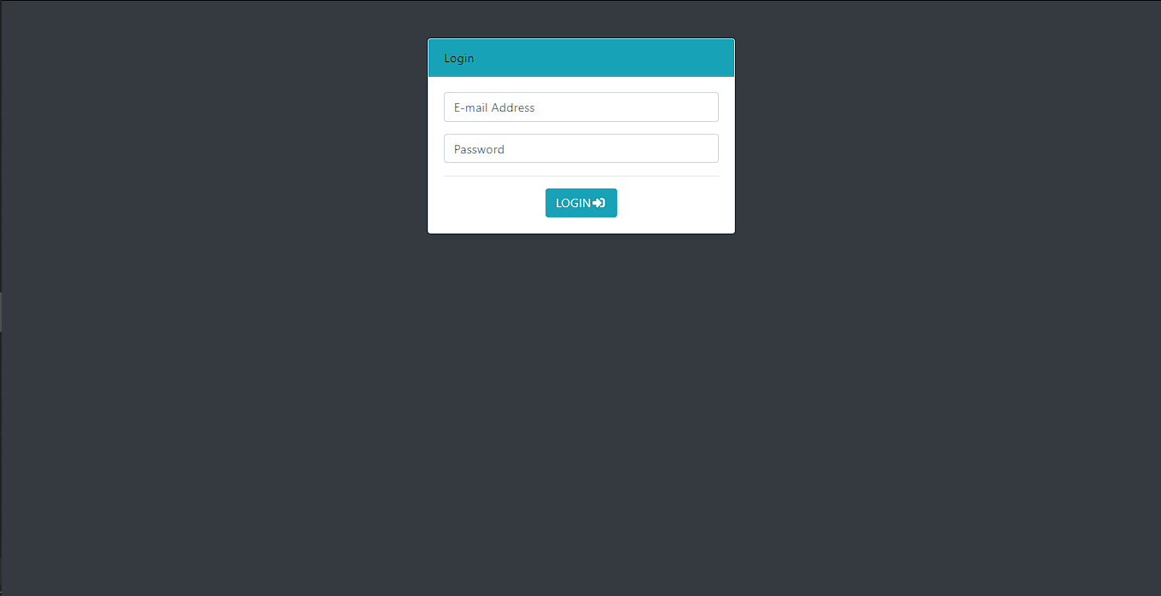
Fig A.1 Login page
Home page

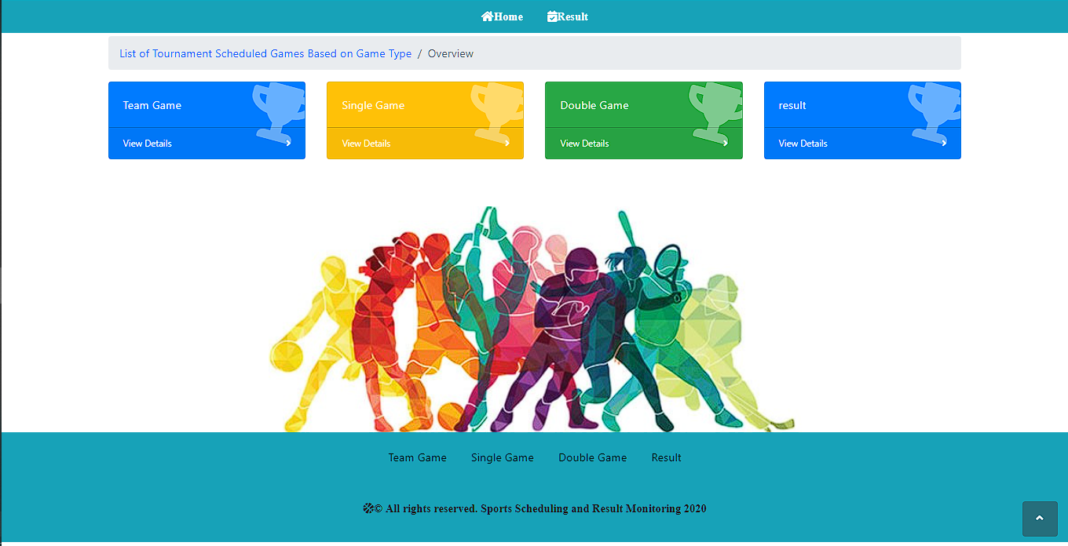
Fig A.2 Home page

Sports event
- Team game
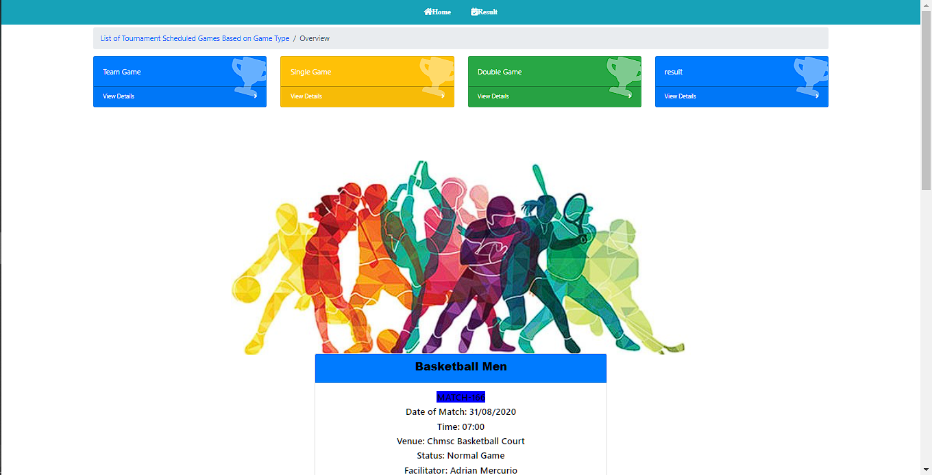
Fig A.3.1 Team game
- Double game

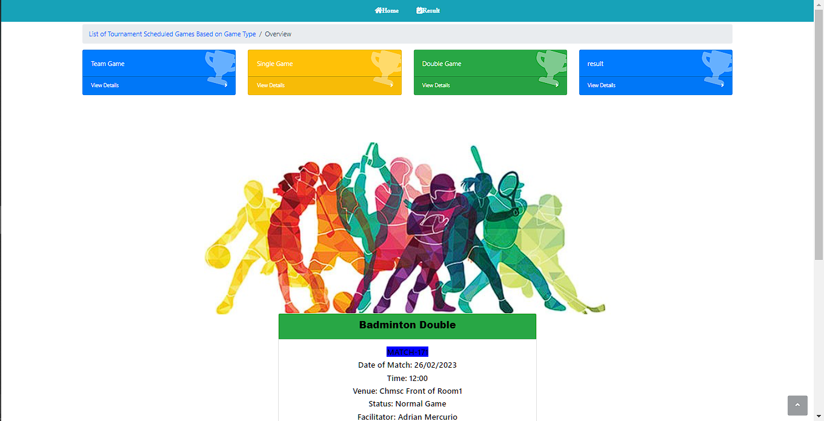
Fig A.3.2 Double game

- Single game

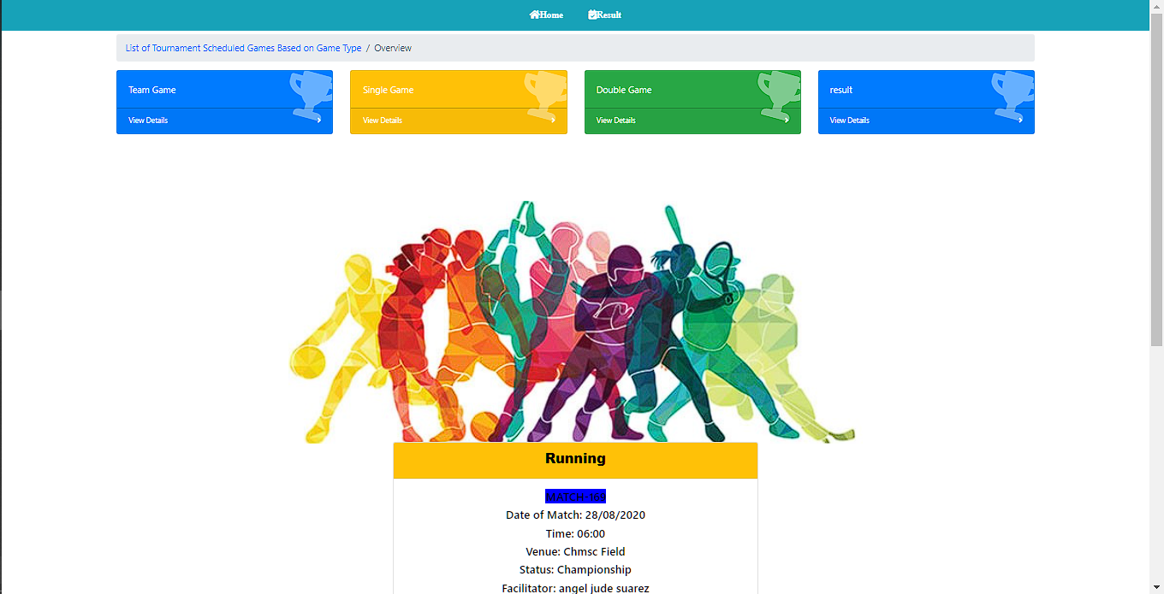
Fig A.3.3 Single game
Tournament schedule

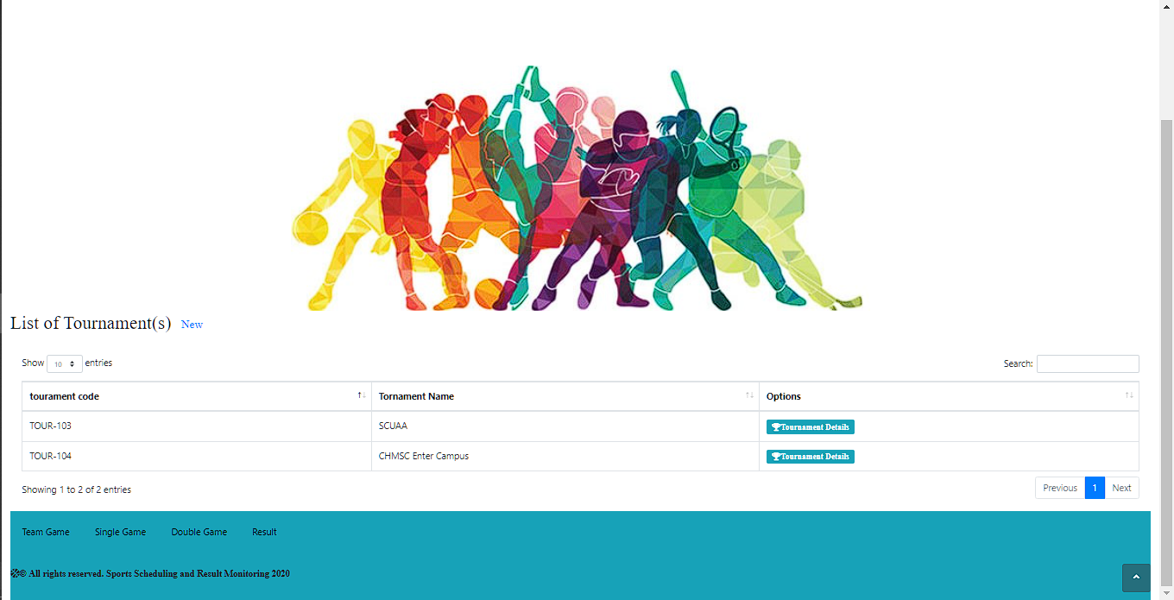
Fig A.4 Tournament schedule

Game schedule

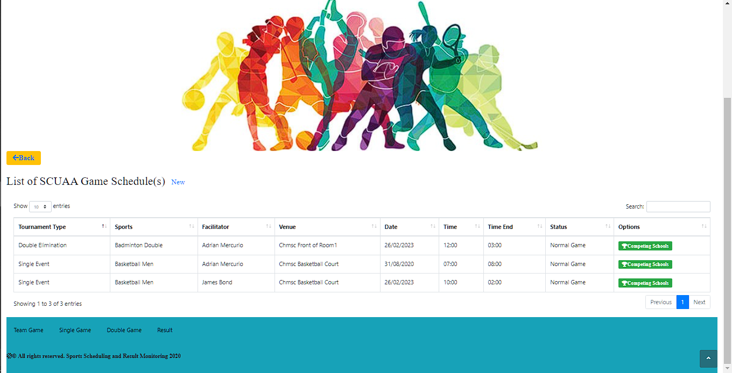
Fig A.5 Game schedule
Adding result

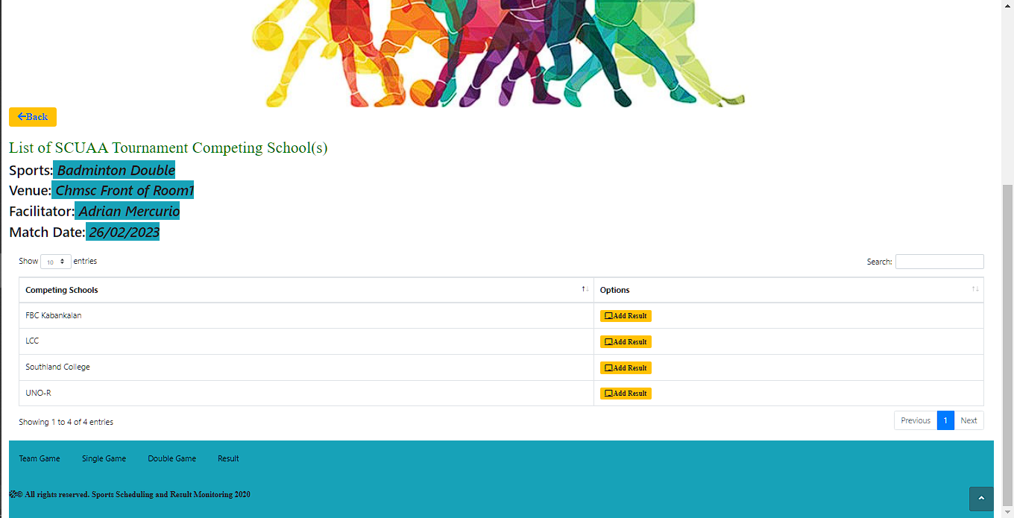
Fig A.6 Adding result

Admin panel

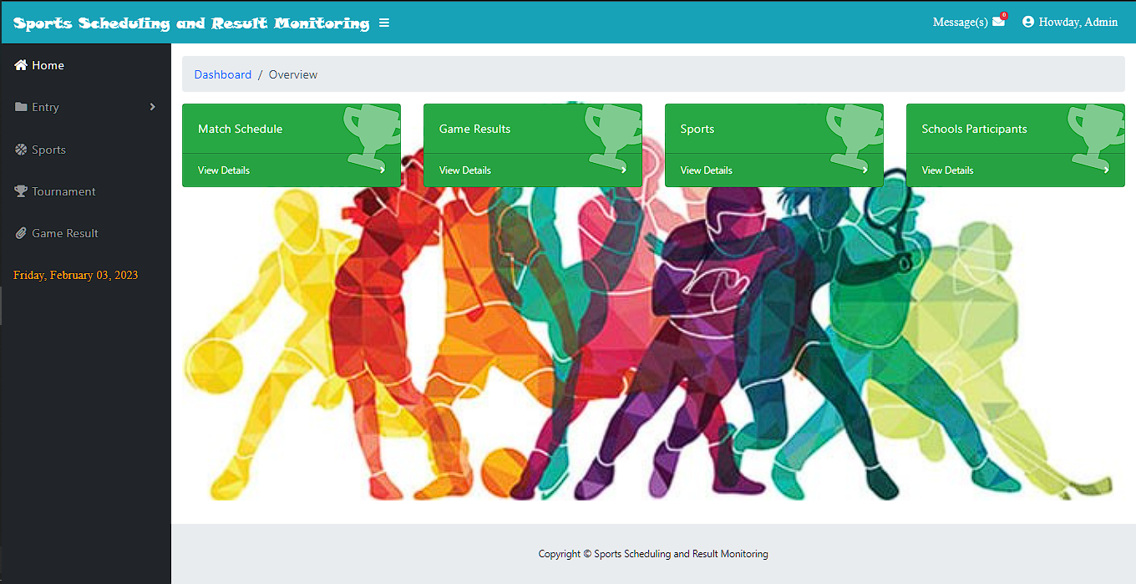
Fig A.7 Admin panel

